Theme Park Wait Times 🏰🎡🎠🎢🎪

**Part 1 -**

### 1. Come up with a project idea you will all like to work on.

As a group we have decided to create a centralised hub catering primarily to those with accessibility needs to help enhance their theme-park experience.

### 2. Submit a document that contains details of your project such as:

**o What is the concept/ what are you building? Think exactly about what needs to be built.**

Our project aims to create a web application that improves the customer experience at theme parks. There are two main avenues we aim to take to meet this goal.

* Firstly, by providing additional information about various accessibility features available and other facilities at selected theme parks.
* Secondly, by accessing data from an API that informs users about the likely wait time for specific rides at the selected theme park. This is critical for those with accessibility needs.

### 3. Who will this help? Who’s your target audience?

* **Those with disabilities/accessibility needs** - to understand where there’s facilities in place to cater to them and make their visit as smooth as possible
  + Currently, this information is fragmented across multiple theme-park applications and websites - our project aims to create a centralised location for this info to be easily accessed
  + Understanding wait times is critical for those with additional needs
* **Thrill-seekers** - want to maximise time spent on rides and not waiting so the application can help them plan their visit efficiently
* **Families with young children** - to help plan their day and work around various services available inc. those for young kids

### 4. How will you be working? What tools will help with that?

**Technologies:**

* UX/UI - [Figma](https://www.figma.com/design/hFIFpMzMrt3tGaZAT0grhy/MUI-(Material-Design-Component-%5B%E2%80%A6%5D-For-React)-(Community)?node-id=629%3A234&t=39OxAskW6C4De4Ne-1)
* Frontend - React, CSS
* Backend - ExpressJS; NodeJS (to confirm)
* Database - We will store accessibility info using mySQL, making API calls to this to retrieve the theme-park relevant data.
* API - <https://queue-times.com/pages/api> (free to use - just need to give credit on the application somewhere)

Work style- agile? waterfall?

### 5. How are you going to organise the workload? Who does what and when?

**Please give us feedback on best way to organise this**

|  |  |  |  |  |  |  |  |  |  |  |
| --- | --- | --- | --- | --- | --- | --- | --- | --- | --- | --- |
| **Team member** | **Definition** | **API** | **Frontend** | **Backend** | **Database** | **Git** | **Read.me file** | **Project doc** | **Presentation** | **Review** |
| **Sarah** | **x** |  |  |  |  | **x** |  |  |  | **x** |
| **Zuzanna** | **x** |  |  |  |  | **x** |  |  |  | **x** |
| **Beth** | **x** |  |  |  |  | **x** |  |  |  | **x** |
| **Warda** | **x** |  |  |  |  | **x** |  |  |  | **x** |
| **Majella** | **x** |  |  |  |  | **x** |  |  |  | **x** |
| **Bronwen** | **x** |  |  |  |  | **x** |  |  |  | **x** |

* To update

### 6. What are the main features of your project?

**Maximising Enjoyment**

* Wait times per ride - user can filter by theme park and/or ride

**Efficient Planning**

* Users can also check if the ride is open or not - especially if they plan to visit a park for a specific ride - can be used as a reassurance to avoid disappointment
* The application should estimate how long a customer would need to go on all the rides in one day (based on wait times for all planned selected rides and opening/closing times)
* Allow users to favourite their favourite theme parks and/or rides - especially useful for those thrill seekers who re-visit their favourite parks and want to minimise wait times
* Promoting inclusion **-**Ensuring all can access the rides by providing information in one place to help with planning

Extended functionalities (TBC)

* Push notifications to users about significant changes in wait times or ride closures - based on their favourite rides

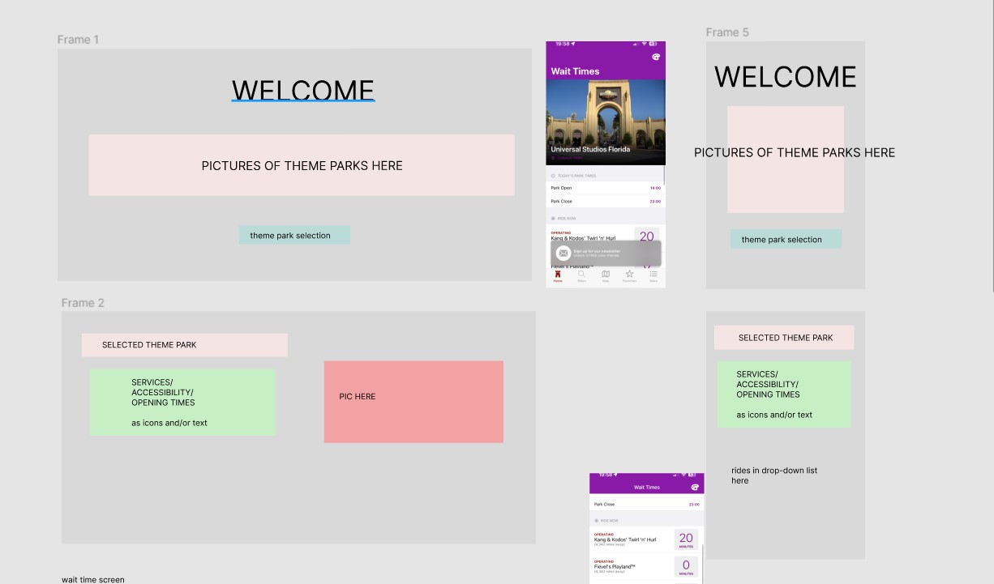**Part 2: screenshots of mock up wireframes**

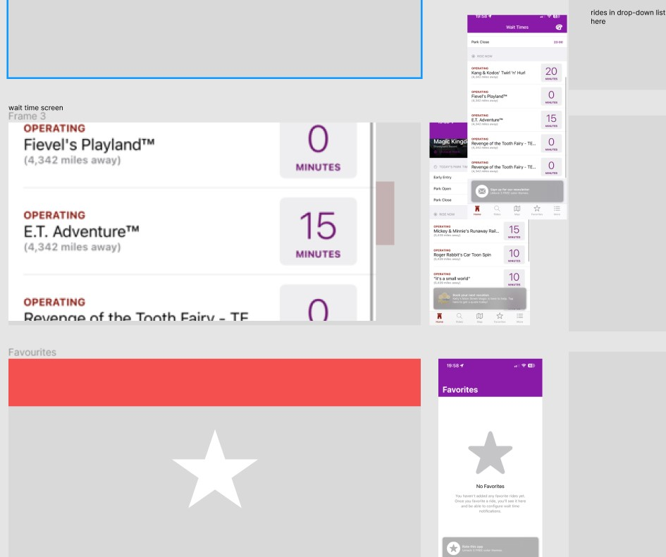

**Part 3: screenshots of our App with Hobbies**

